Lab 6 – Extracting Watershed Hydrography from a DEM

## Background

The extraction of hydrographic features, such as watersheds, from digital elevation models is a common component of many geomorphic and hydrologic studies. Topographic watershed analysis can be useful as a first step in analyzing geomorphologic and/or hydrologic problems such as calculating flow velocity, discharge, or sediment load. The purpose of this lab is to identify individual watersheds and stream hydrography directly from terrain data.

## Problem Statement

Hydrology is an important part of earth science studies because water affects almost all aspects of life on earth. Chemical reactions are dependent upon the water availability and water is a significant factor in rock weathering. All biological species are dependent upon water for survival. Hydrological studies include determining sediment load, nutrients, pollutants, and runoff. Maguire et al., (2005) discusses the use of hydrologic modeling within a GIS to simulate water velocity, depth, discharge, and quality throughout a domain of interest, such as a watershed, river channel system, or groundwater aquifer. Hydrologic modeling integrates discrete and continuous data. Time is also considered (Maguire et al., 2005).

The first step to most hydrological studies is to **delineate watersheds**. The U.S. Geological Survey defines a watershed as an area of land that drains all the streams and rainfall to a common outlet (USGS, 2011). Watersheds can be divided into smaller units or lumped into larger units depending upon the number of incoming streams. When delineating watersheds with GIS, the shape and size of the watershed is dependent on the resolution of the DEM. The terrain of the watershed determines the direction water will flow and its accumulation.

Assume that you need to identify the drainage basin above a specific location to create a watershed model that simulates river runoff through that watershed. Your goal is to extract polygon representations of the watersheds in the region and polylines of the major flow networks using only a DEM and a ModelBuilder model. You will identify these flow networks and medium scale watersheds (i.e. 20-40 watersheds for the entire map).

Create a ModelBuilder model and output map with about 20 to 40 sub-watersheds for this small basin. Overlay your resulting watershed boundaries and polyline rivers on a satellite image of the watershed to determine how well your results match the flow paths shown in the image. Also compare your stream results to USGS National Hydrographic Data (NHD) to see how well your results compare to the official USGS stream network.

## Data

National Elevation Data DEM: For **Part 1**, download the Rock Canyon raster data provided on Learning Suite. For **Part 2**, you will download different DEM data for a different area that you choose and run it through your ModelBuilder model an generate a second map. For Part 2, you can use the following site to find other DEM data: <http://gis.utah.gov/data/elevation-terrain-data/10-30-meter-elevation-models-usgs-ned/>.Click on the **Raster App: 30-meter USGS DEMs**. Using the interactive map, approximately locate your area of interest. Draw a polygon (i.e. square) around the general area. After you double click to define the area of interest, open the results tab and download the DEM.

NHD Streams Shapefile: <http://gis.utah.gov/data/water-data-services/lakes-rivers-dams/>

Download the NHD Streams shapefile for every stream in Utah. You will be using this shapefile to compare our delineated streams to the actual streams shown in this dataset. You will not be using these streams in the model.

## ModelBuilder Tools

You will use the following new tools in this exercise along with tools from previous labs:

Fill: Fills in the areas called pits (or sinks) in a raster. A pit is one or more cells which has no downstream cells (I.e. where what gets ‘stuck’) The tool generates a raster where all the water flows out of the watershed.

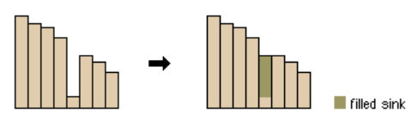

Flow Direction: Creates a raster of flow direction from each cell to its downslope neighbor. It assigns numerical values for the direction that the water is flowing. (North = 64, Northeast = 128, South = 4, etc.)

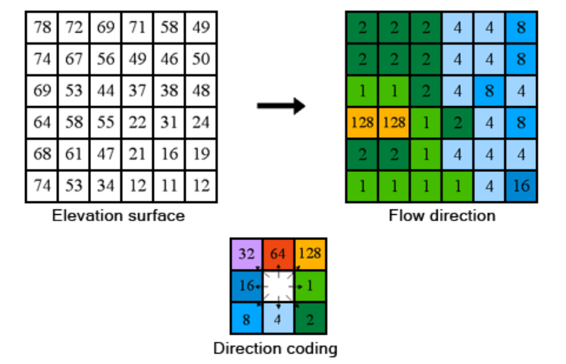

Flow Accumulation: Measures the drainage area in units of grid cells. The cell you are looking at does not include the cell count of itself.

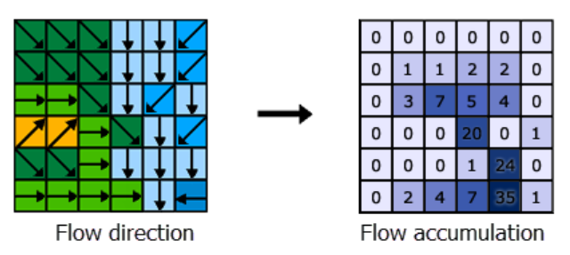

Watershed: Delineates a drainage area at a given scale. The scale can be easily changed within ArcGIS Pro by changing the threshold number of cells that will contribute to the watershed. Cell threshold is the minimum number of cells that, when flowing together, are assumed to represent a stream. Low threshold results in a lot of smaller streams, and a large threshold will result in fewer larger streams.

The threshold is set using the **Greater Than** tool to identify “stream” and “non-stream” cells. For example, if the user defines the threshold number as 200,000 cells, then all cells which have an upstream area of over 200,000 cells will be flagged as ‘stream’ while everywhere else is considered ‘non-stream.’ This does not mean that there is actually flowing water at that point on the landscape, but it is an indicator that there could be a river or stream at that location. The conditional statement to identify grid cells with a large upstream area – in this example, 200,000 cells – looks like this: Con("%flowAccum1%" > 200000,1,0).

Raster to Polyline/Polygon: Creates a polyline or polygon feature based on raster cells with similar values or values within certain ranges. You will use this to convert your resulting raster of watersheds and raster of stream grid cells into vector shapefiles.

Feature Vertices to Points: Creates a point shapefile from all the vertices of a polyline shapefile. You will use this to find the points that lie at the end of your streams. You will use these points as the outlets of your watersheds.

Mosaic to New Raster: Merges multiple datasets at once. Depending on where you find your data, you may need to combine multiple rasters into one larger raster DEM dataset.

## Example Model

Note that this model assumes that you have several raster data sets that need to be merged or “mosaicked” into a single combined raster before conducting the analysis. For Part 1, we have provided a single raster data set (for Rock Canyon) so you will not need to do the **Mosaic to New Raster** step. However, for Part 2, if your study area includes more than one raster, you may need to include this step. If you are using a single raster, you can enter it in the “Input Rasters” – or you can enter multiple in that parameter.

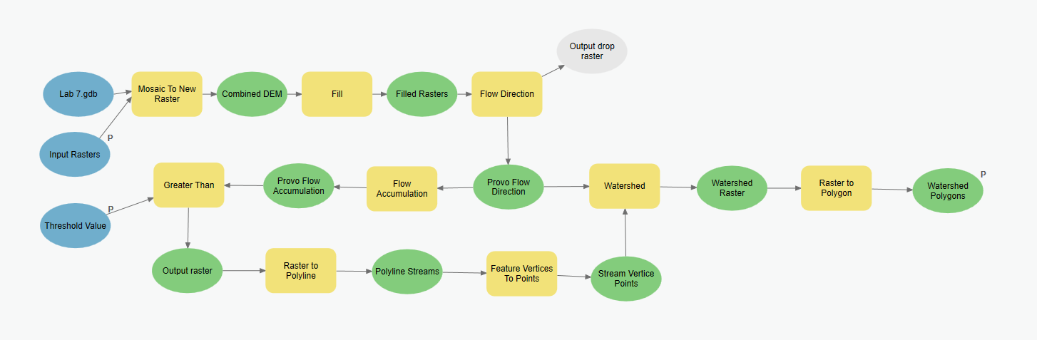

## Complete the Lab

For an advanced GIS student, the information up to this point is all you need to complete the assignment and create an output map from the results. Feel free to try conducting the analysis using only the information provided above, **without referring to the example model**. If you complete the lab only using the information provided above (without using the step-by-step instructions) make sure to indicate this in your lab report to be considered for extra credit. If you need extra help, follow the step-by-step solution below.

## Step by Step Solution

There are several different techniques and algorithms for extracting watershed boundaries and stream flow networks from DEM data. In this lab, you will take the following approach: fill any pits that are within the DEM, calculate the flow direction, compute flow accumulation, create raster flow networks, convert these to polylines (that will represent the rivers), extract watershed areas as raster data, and then convert these watersheds to polygons. This process will work, with minor adjustments, on any DEM. A basic outline of a model that can be used to complete this assignment is shown above.

### Step 1

Use the **Mosaic to Raster** tool to combine the four different raster datasets. If you are working with a single input raster file, then you can skip this step. Select the project’s geodatabase for the **Output Location**. For the **Raster Dataset Name with Extension,** name the raster dataset but do not add an extension attached. No extension is needed because the final raster is inside the geodatabase. The text box only accepts names with 13 characters or less and does not allow spaces. Set **NAD 1983 UTM Zone 12N** as your projection. Change the **Pixel Type (optional)** box to a **32 bit signed**. The elevations recorded are very large float type numbers. If you choose something smaller, you might not retain any large elevation values. The **Cellsize** does not need to be changed. The **Number of Bands** option should be set to **1**. This is because you only have one set of data in the rasters (i.e. elevation). If you were to combine basemaps, you might use the 3 for the RGB bands in pictures. The **Mosaic Operator (optional)** option should be set to **blend** and the **Mosaic Colormap Mode (optional)** option should be set to **match**. These options help combine the two rasters where they overlap and will maintain the whole range of elevations from all the rasters. See Figure 2 for an example of this setup.

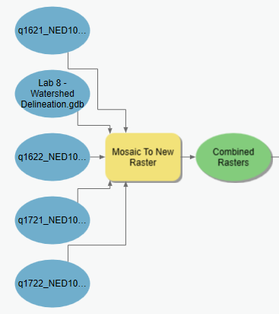

Figure : Mosaic to New Raster Tool in ModelBuilder

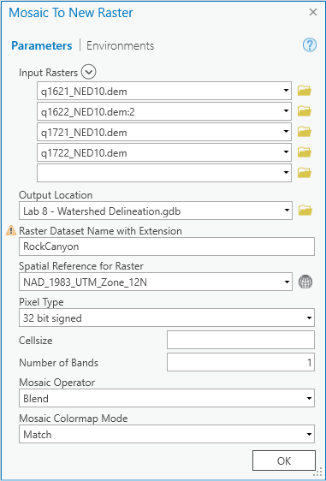

Figure : Mosaic to New Raster Tool Window

### Step 2

If you downloaded raster DEM data off of the web and do not need to use the **Mosaic To New Raster** tool, you can proceed directly to the **Project Raster** tool to set your raster to the correct projection (see Figure 3) Make sure that every DEM in the model is set to the correct projection.

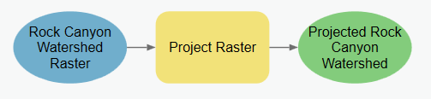

Figure : Using the Project Raster tool in ModelBuilder.

### Step 3

Use the **Fill** tool to fill the pits in the raster. Theoretically, this prevents water from getting ‘stuck’ in a watershed. It allows the water to flow freely out of the canyon (see Figure 4).

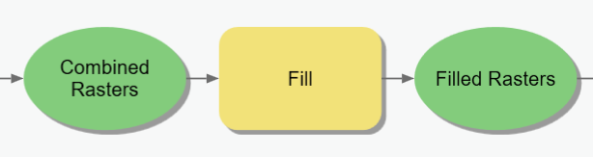

Figure 4 – The Fill tool in ModelBuilder.

### Step 4

Use the **Flow Direction** tool to determine the flow direction from cell to cell. Use the output raster from the filled raster you created in the last step. Leave the output drop raster option blank (see Figure 5). Set **Flow direction type** to **D8.**

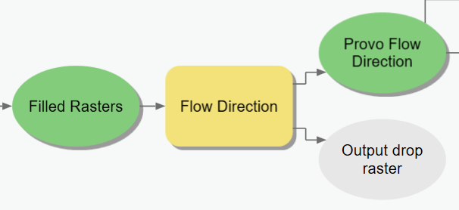

Figure 5 – The Flow Direction tool in ModelBuilder.

### Step 5

Use the **Flow Accumulation** Tool to calculate the flow accumulation in each cell based on the flow direction found in Step 4 (see Figure 7). Leave the **Input Weight Raster** blank, a default weight of 1 will be applied to each cell.

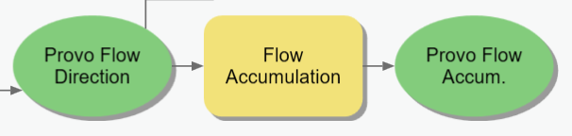

Figure : Flow Accumulation Tool in ModelBuilder

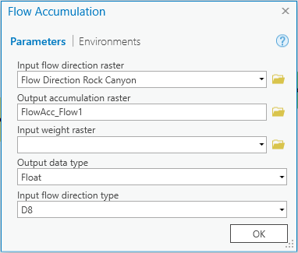

Figure 7 – The Flow Accumulation tool window

### Step 6

Use the **Greater Than** tool to define the threshold and to get a final number of watersheds, between 20 and 40. The threshold in this lab is the number of cells that will contribute to streams (around 5,000 or 10,000 cells).

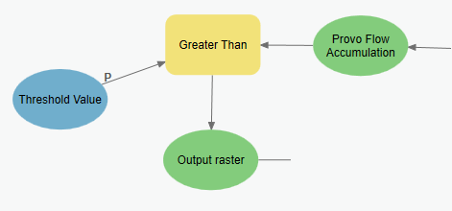

Figure 8 – The Greater Than tool in Model Builder.

You may need to repeat and edit this step to refine the number of watersheds so that they meet the requirements of having 20-40 sub-watersheds within the Rock Canyon watershed. The threshold will be different depending on the study area and raster size to get the required number of watersheds. You may even want to make the SQL statement a parameter for the model so that you can edit this step without having to be in the editor window of ModelBuilder.

### Step 7

Use the **Raster to Polyline** tool to convert the pixels that have been defined as a stream to a polyline shapefile. The output of this tool provides us with the streams for our Rock Canyon watershed. Right click and select **Add to Display**. This will show your delineated streams in comparison to the measured streams found from the NHD shapefile. This also creates a unique situation where one of your desired outputs is both an intermediate and output dataset.

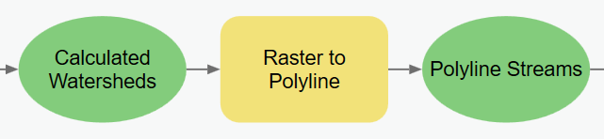

Figure 9 – The Raster to Polyline tool in Model Builder.

### Step 8

Use **Feature Vertices to Points** tool to calculate the end points for the rivers. The end points will become the outlets for the watersheds that your model will extract. (Find the end points of the polylines)

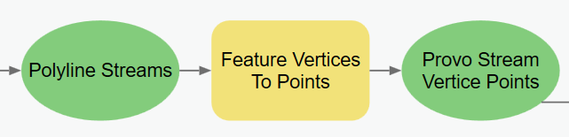

Figure 10 – The Feature Vertices to Points tool in Model Builder.

### Step 9

Use the **Watershed** tool to create a watershed raster layer from the flow accumulation and flow direction that were delineated in previous steps. By using the flow direction raster and the points from the different streams, this tool assigns cells in the same watershed a unique value to identify the region.

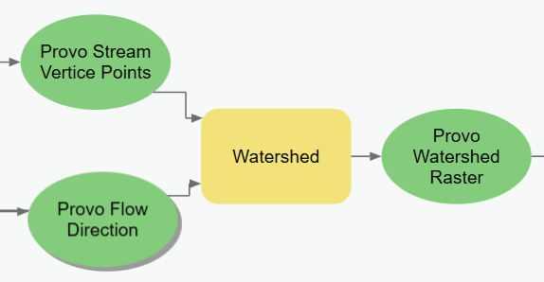

Figure 11 - The Watershed tool in Model Builder.

### Step 10

The final watershed polygons are created from the watershed raster created from Step 9 by using the cell values for each of the regions into polygons. At the completion of this step, the shapefile can be added to the map. Make sure to **Add to Display**.

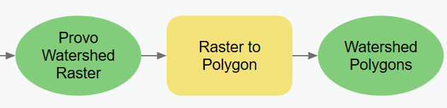

Figure 12 – The Raster to Polygon tool in Model Builder.

### Step 11

After adding the shapefile to the map, you will have more streams and watersheds than are part of the Rock Canyon watershed. Refer to the example map provided for this lab for the approximate shape of the watershed. Manually create a shapefile of the watersheds and streams that are only part of the canyon. Select the Watershed layer and open the **Edit** tab. Use the **Select** tool and shift-click all the watershed polygons within the appropriate area. After selecting the desired polygons, right-click the layer in the **Table of Contents** and select **Data** and then **Export Data.** Use the browse button to find a suitable folder to save the selected features. Change **Save as Type** option to **shapefile**. Follow a similar process selecting the delineated and online streams.

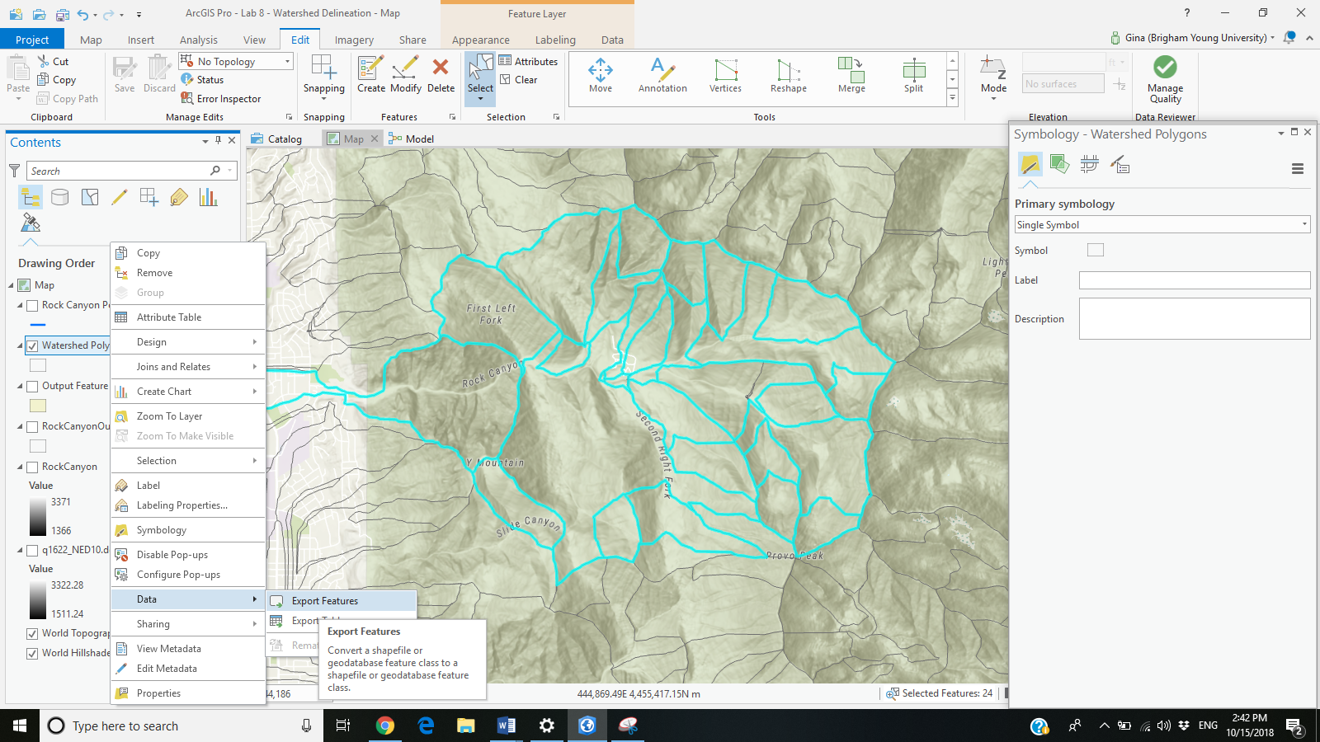

Figure : Selection of the Watersheds in Rock Canyon.

### Step 12

Please refer to course lecture material to recall how to create a ModelBuilder **tool interface** that allows a user to specify the input data, output data, and the flow accumulation threshold value. Make sure to include a screen capture of your custom tool interface in your project report! It might look something like Figure 15.

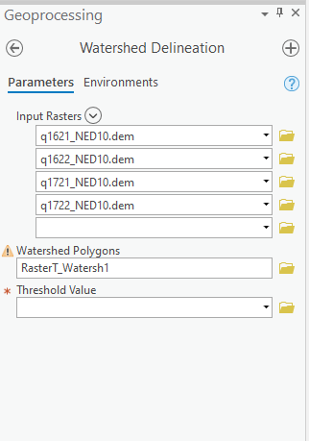

Figure : Example Custom Tool Interface for your ModelBuilder model.

## Deliverables

Using the data provided, construct a single ModelBuilder model with a customized graphical user interface (**tool interface**) that will prepare all your input data for the terrain analysis, conduct the analysis, and create a map from the analysis. Your resulting map should show the original DEM in shaded relief with the derived watershed polygons in a transparent or semitransparent symbology and the two sets of stream networks clearly displayed (the given data and the stream network you extracted from the DEM). Prepare a brief report that contains your model, the steps taken in the model building process, describes your results for the project, and includes a final map of your results.

**Bonus**. Identify your own area of interest and download DEM data for this area. Re-run your model with this second data set using the tool interface you created in Part 1. Prepare a second map showing the delineated streams and watersheds for this new study area.

Review the rubric for the full requirements for this lab exercise.

## References

Maguire,D.J., Batty, M., Goodchild, M.F. GIS, Spatial Analysis, and Modeling. 1st Edition. Esri Press 2005.

U.S. Geological Survey (USGS) (2011) http://ga.water.usgs.gov/edu/watershed.html.

## Example Map

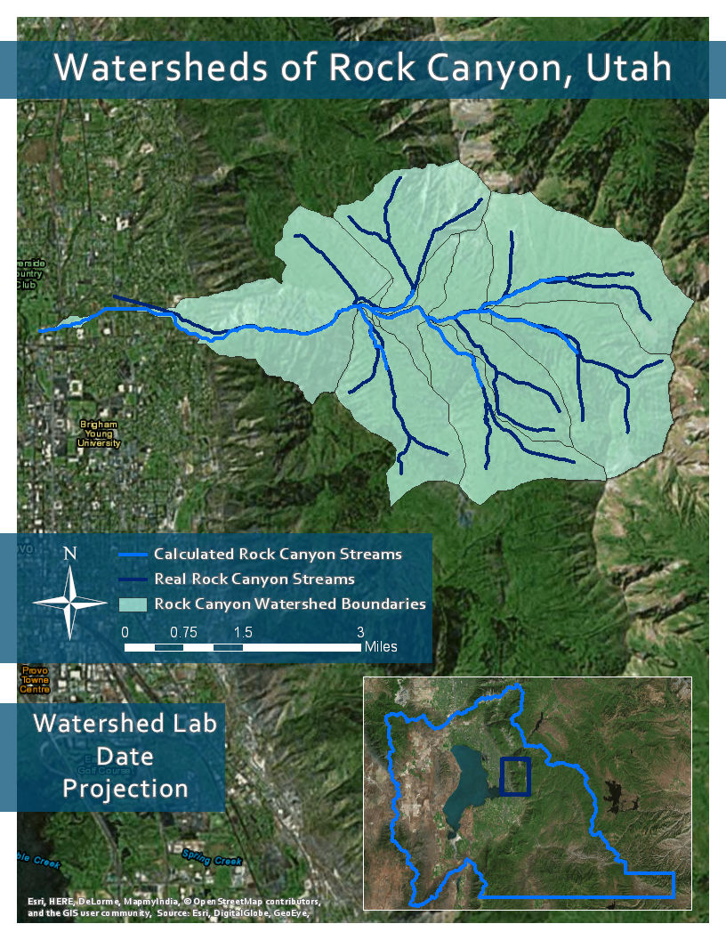

## Rubric for Extracting Watershed Hydrography from a DEM

|  |  |
| --- | --- |
| **Item** | **Points** |
| Assignment Title, Name, Date, Course | /2 |
| Brief summary of the requirements of the project in your words | /3 |
| Describe your model   * List each of the tools used: (1 pts.) * List tool settings applied for the analysis (1 pts.) * List all input, intermediate, and output datasets: (1 pts.) * Describe each input dataset including type (point, line, polygon, raster) and the source of the data: (1 pts.) * Describe each output dataset (point, line, polygon, raster): (1 pts.) | /5 |
| Show your model   * One or more full pages (8.5 x 11) showing your model (5 pts.) * All text is readable (10pt. font minimum) (3 pts.) * All tools and data sets are shown (2 pts.) | /10 |
| Show a ModelBuilder Tool interface   * Include user interface for setting the input data (3 pts.) * Include user interface for setting the output data (3 pts.) * Include user interface for adjusting the SQL statement that specifies the threshold value (3 pts) * Customize the title and other labels (1 pt.) | /10 |
| **Map your results.** Make a full-page map showing the results of your watershed analysis for the provided Rock Canyon data.   * Map Title: (1 pt.) * Neat Line: (1 pt.) * North Arrow: (1 pt.) * Scale Bar: (1 pt.) * Text box with author name, date, map projection: (1 pt.) * Delineated watershed boundaries, stream network, and given stream network shown: (5 pts.) * Each data set clearly symbolized: (1 pt.) * Visible basemap showing underlying terrain data: (1 pt.) * Labels indicating NHD versus delineated stream network: (1 pt.) * Zoomed to an appropriate scale for viewing analysis results: (1 pt.) * All text is legible on printed map: (1 pt.) | /15 |

|  |  |
| --- | --- |
| Discuss your results   * How does your delineated stream compare to the NHD data? How does the watershed boundary compare to the terrain visible in a basemap? (3 pts.) * Are your results as expected or did you find anything interesting or different than expected? (2 pts.) | /5 |
| Bonus: Rerun the analysis on another data set | Grader Discretion |
| **Total points possible:** | /50 |